**SQL Project Report – Banking Analysis**

**Eric Ye**

**Tareq Jaber**

**Metro College of Technology**

**April 14th, 2021**

**Introduction:** Microsoft SQL Server is a relational database management system, used widely for storing and retrieving data, as requested by other software applications. Within these databases, data is stored and cleaned, and sent to other software applications for further statistical analysis. The following SQL project includes the Bank database creation of the series of tables and sample observations in Phase 1. In Phase 2, 10 cleaning/analysis questions are then assigned, to be performed using SQL server management. The following sample analysis and question for the project is shown below

**Questions:** Take a deposit/ withdrawal as a parameter and update CurrentBalance value for that particular account.

Depending on whether it is a deposit or withdrawal, we can create a procedure which subsequently adds or subtracts the given money input from the current balance in the account.

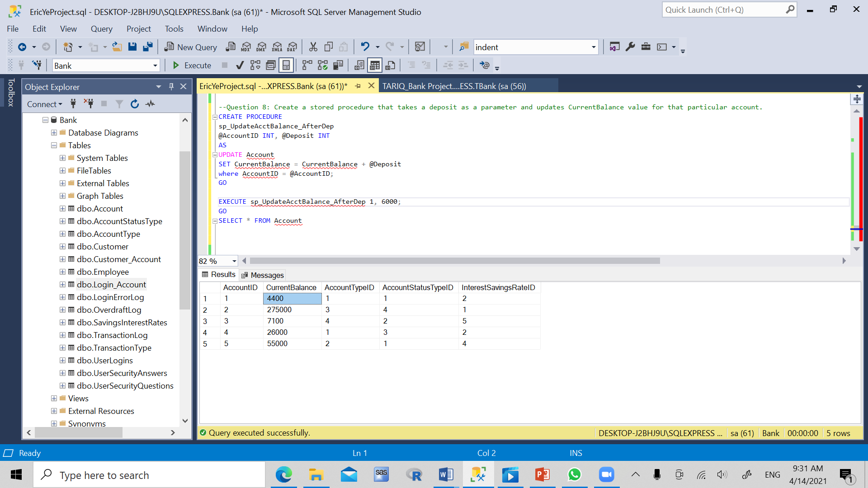

*Figure 1:* Original table is shown here, with variables AccountID, CurrentBalance

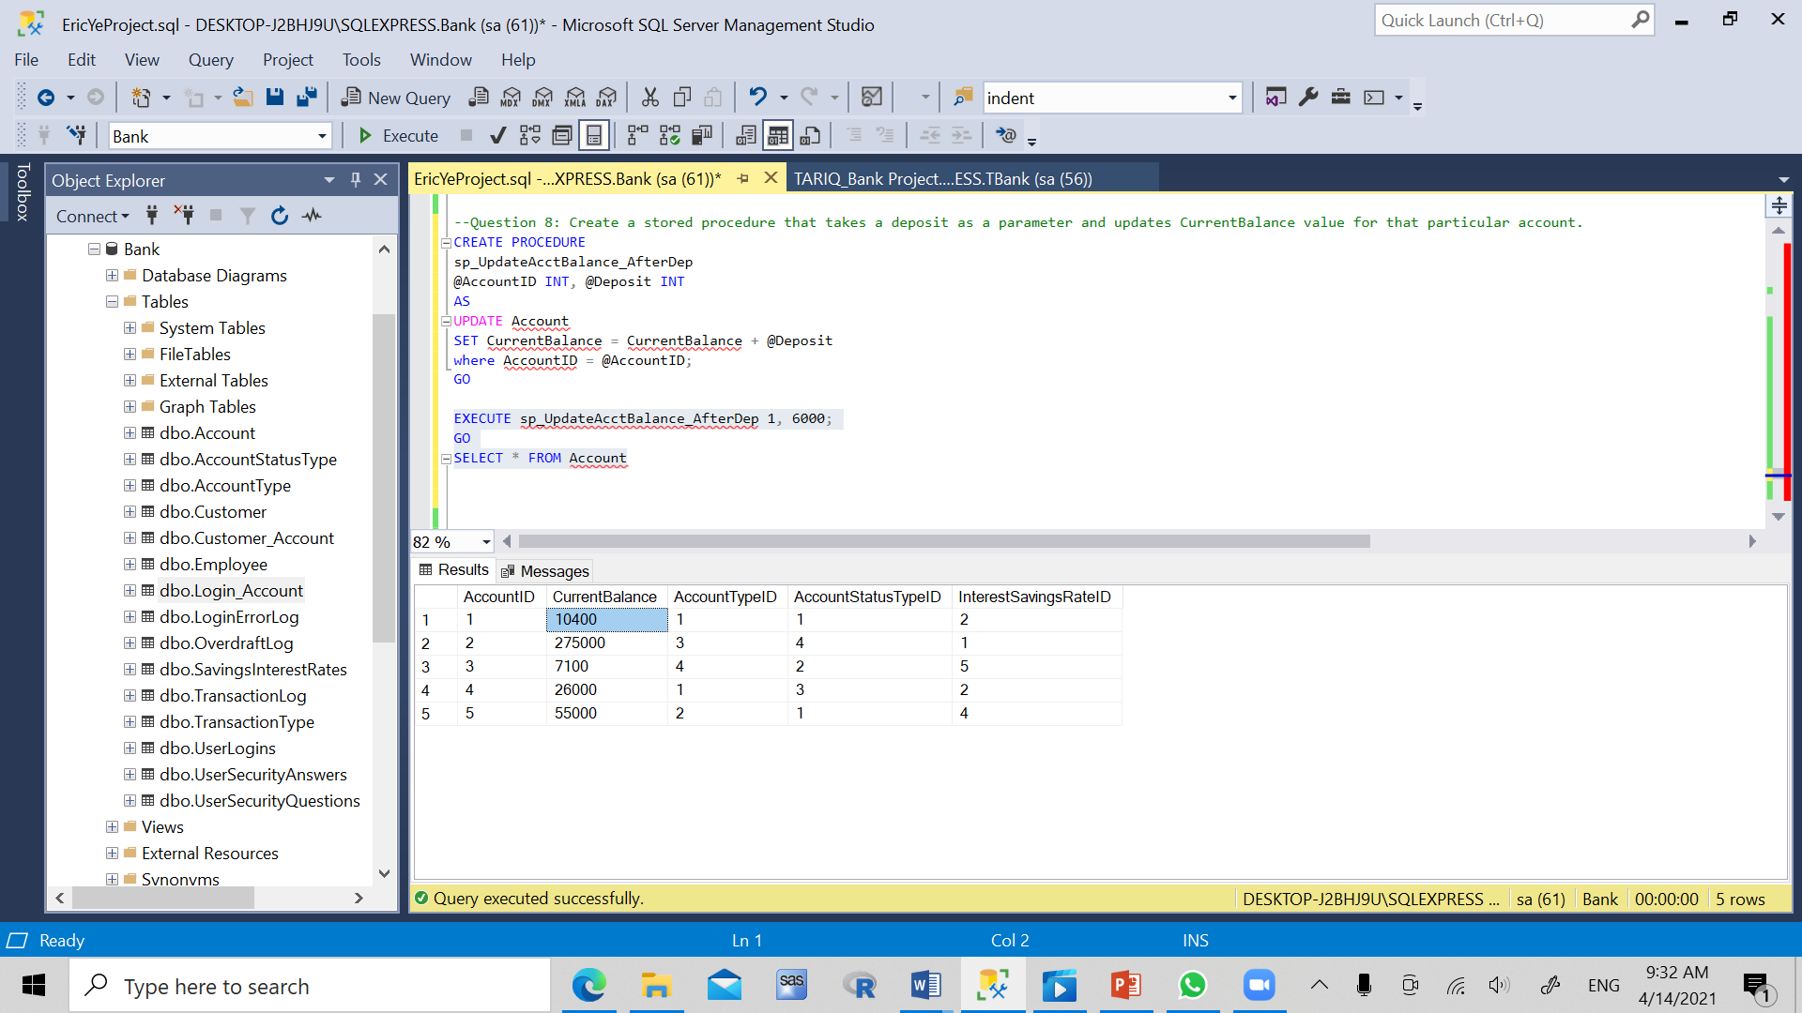

*Figure 2:* The resulting table with a deposit of $6000. The procedure takes in an AccountID value of 1 and deposit amount of 6000.

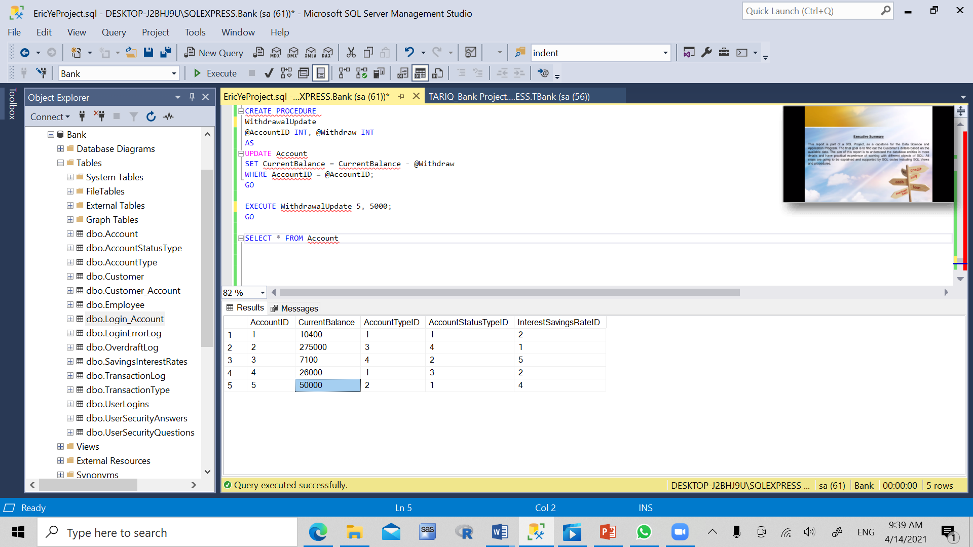

*Figure 3:* The resulting table with a withdrawal of $5000. The procedure takes in an AccountID value of 5 and withdraw amount of 5000.

**Conclusion:** We can see that SQL Server is useful for so many things. It is used to store countless amounts of essential data. Where ever there is data management, SQL can be used. It has so many functions, from creating brand new tables catered to every need, to creating procedures that can keep updating values in real time, similar to the above example. In conclusion, SQL Server Management is an essential tool in data science, keeping databases clean, user-friendly and organized.